How to connect the
DomStick with your project

In this guide, we will show you how to connect the DomStick to your project using a Bluetooth connection.
First, it’s important to understand that the HC-05 Bluetooth module works as a slave in its normal mode. This means it cannot start a connection by itself — it must be connected to by a master device. For example, when you use a mobile app to connect to the module, your phone acts as the master and the HC-05 acts as the slave.
However, what makes the HC-05 special is that it can work in both master and slave modes. This means we can configure one module to act as the master and another as the slave, allowing them to connect directly to each other.

Since both Bluetooth modules are initially set to slave mode, neither of them can start the connection. To solve this, we need to change the mode of one module, so it acts as the master and starts the connection process. After that, we can set this master module to automatically connect to the specific slave module by using the slave module’s MAC address.

We can get the mac address from the slave module and pass it to the master module so when both are powered up the master will automatically start connection with the slave without any further a do lets start configuring the Bluetooth modules.
Now that we understand what we have to do, we now need to setup the environment to make our work.

Setting up the Environment
We have to create this Arduino circuit so that the Arduino can connect to the Bluetooth module and configure it

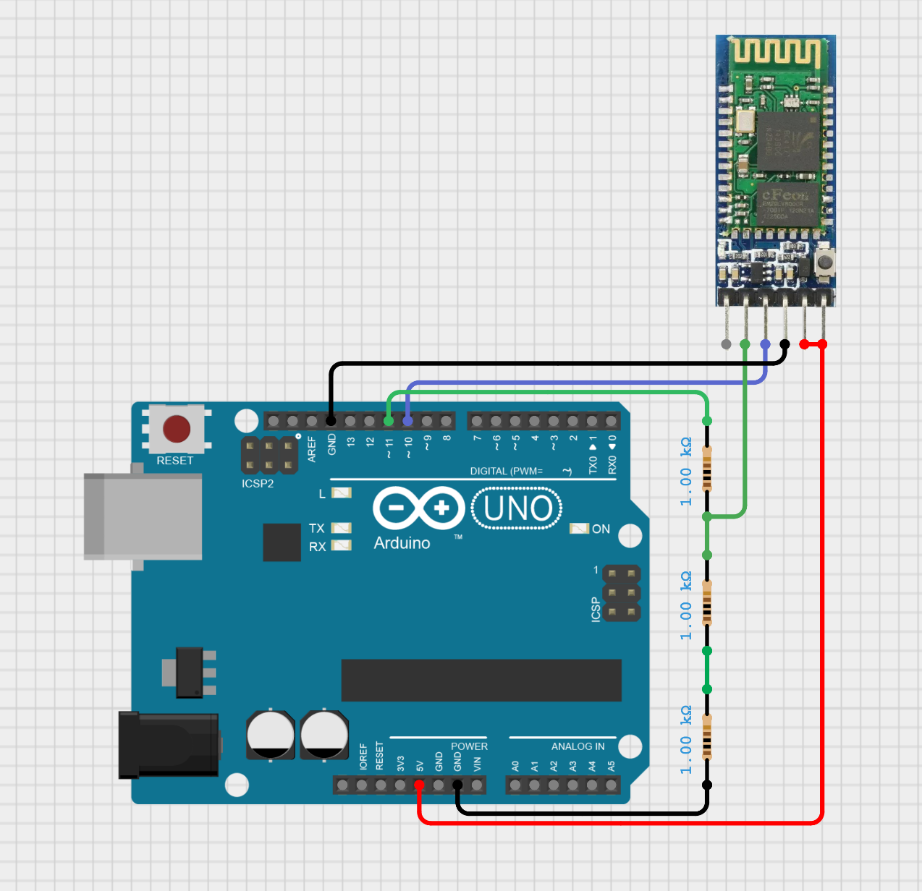

After this we have to write Arduino code that can read the commands from your laptop and send it to the Bluetooth module to respond to it.

But we have to make the Bluetooth module enters the AT mode so that the module be ready to execute the commands and this is done by making the enable pin connected to 5V or 3.3V when it is powered up and as long as you are in the AT mode the enable pin should stay connected to the 5V or 3.3V.

After connecting the above circuit, program the Arduino with this code:

#include <SoftwareSerial.h>

#define BT_RX 10 // Arduino RX (connect to HC-05 TX)
#define BT_TX 11 // (connect to HC-05 RX through voltage divider)

SoftwareSerial BTSerial(BT_RX, BT_TX);

void setup() {
Serial.begin(9600); // Serial Monitor
BTSerial.begin(9600); // Default baud rate for HC-05 in AT mode

Serial.println("Enter AT commands:");
}

void loop() {
// Forward data from Bluetooth to Serial Monitor
if (BTSerial.available()) {
Serial.write(BTSerial.read());
}

// Forward data from Serial Monitor to Bluetooth
if (Serial.available()) {
BTSerial.write(Serial.read());
}
}

After programming the Arduino and connecting the Bluetooth module circuit, open the Serial monitor and adjust its baud rate to 9600 and make the mode “both NL & CR” as shown in the following image:
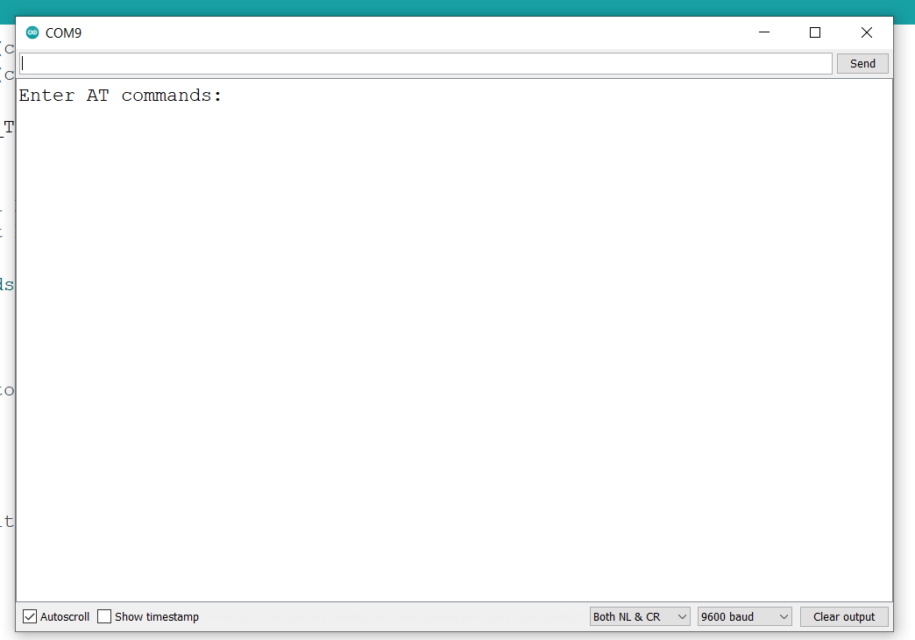

Configuring the Slave Module
Before configuring try typing “AT” if it respond with ok then the connection is established well and the module entered the configurations mode.

There are 4 steps now that we need to go through:
- First we need to rename the module using this command:
AT+NAME=DomStickSlave
You can choose any name as you like rather than DomStickSlave, this step is not mandatory but it is better to do it to distinguish between modules in the future.

- Make sure that the module in Slave mode from this command:
AT+ROLE=0
- Show the module MAC Address as it will be used in the master module configurations:
AT+ADDR?
The address output is something like this 23:10:A01398, store it as it will be used later.

- Adjust the baud rate, stop & parity bits
AT+UART=9600,0,0

Now that’s our slave is done, let’s go to the Master module.

Configuring the Master Module
There are 5 steps:
- Rename the Module:
AT+NAME=DomStickMaster
- Make it in master mode:
AT+ROLE=1
- Mae the module connect to specific module
AT+CMODE=0
- Save the slave address for binding, and make sure to replace the colons : in the slave MAC Address(23:10:A01398) with a comma ,
AT+BIND=23,10,A01398
- Adjust the baud rate, stop & parity bits
AT+UART=9600,0,0

Now that we have configured the master and slave modules, all we need to do now is to open both modules, the master will search for the slaves using the slave’s MAC Address and if it found the slave it will automatically connect to it, you will find that both modules blinks fast until they are connected with each other the blink speed will decrease identifying that they are connected.

